#LockdownLearning: Design your own food packaging
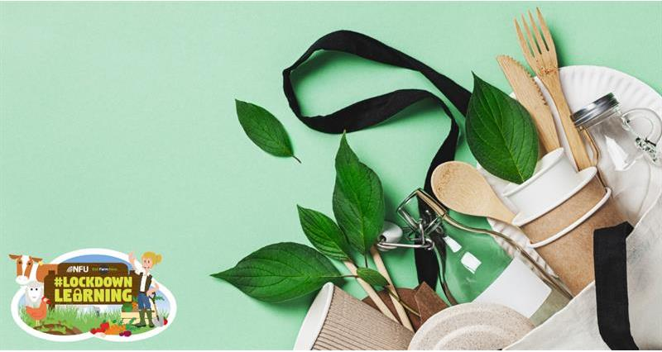
Our Education team has 3 fun activities for you to try at home to get you thinking about food packaging and the environment.
Complete this series of tasks to find out about how food is packaged and how we can improve food packaging to help protect the environment. Before you start, take a look at these Power Point slides to give you a better understanding of food packaging.

Task 1: Interview an elderly relative
To find out how people shopped and what packaging looked like years ago, contact an elderly relative and ask them some questions! Questions you might like to ask include:
- Where did people go shopping?
- How was the food packaged?
Don't forget though, with lock down restrictions still in place be sure to only contact your elderly friends and relatives virtually via phone call, FaceTime, Skype or Zoom.

Task 2: Healthy picnic
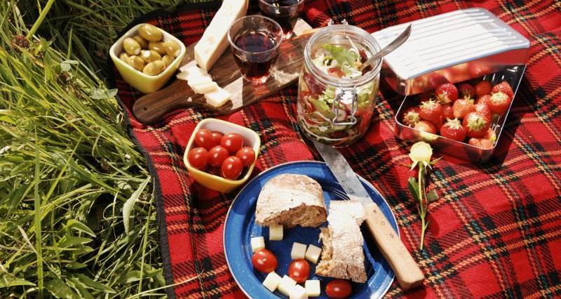
Now you've got more of an understanding about food packaging, it's time to design your own healthy picnic. Your picnic should...
- Avoid extra plastic food packaging
- Avoid disposable plastic cutlery and glasses
- Include plenty of healthy food and drink
Remember that due to the current situation, picnics out and about are not allowed, but that shouldn't stop you rom enjoying it. Why not plan a picnic in your own garden, or even inside!

Task 3: Design a poster
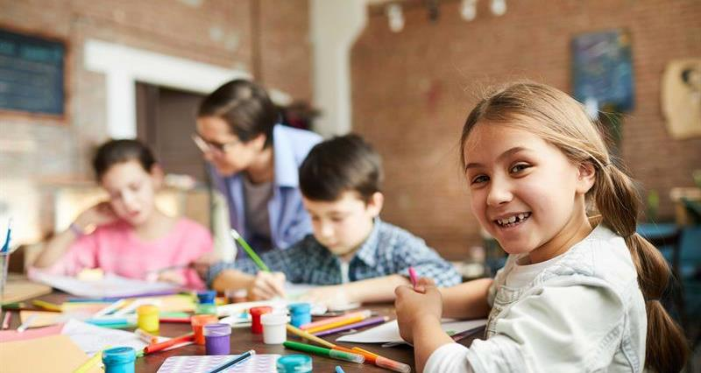
Sharpen your colouring crayons and dig out the coloured paper - it's time to get creative. Now that you've looked at the pros and cons of packaging and how it can be improved, design a poster to show consumers and manufacturers why they should apply the 'Six Rs' to food packaging.
The 'Six Rs' can be applied to help reduce the environmental impact of food packaging.
- Rethink - do things differently, how can we shop differently?
- Refuse - don't use extra unnecessary packaging
- Reduce - make less waste by using a resuable shopping bag
- Reuse - use again
- Recycle - turn waste back into useful things
- Repair - mend something instead of throwing away
Make sure that your poster is informative, with relevant titles, pictures and captions. If you're feeling extra creative, you could even design a prototype using some materials from your recycling box!
https://www.countrysideonline.co.uk/back-british-farming/education/lockdownlearning-design-your-own-food-packaging/

