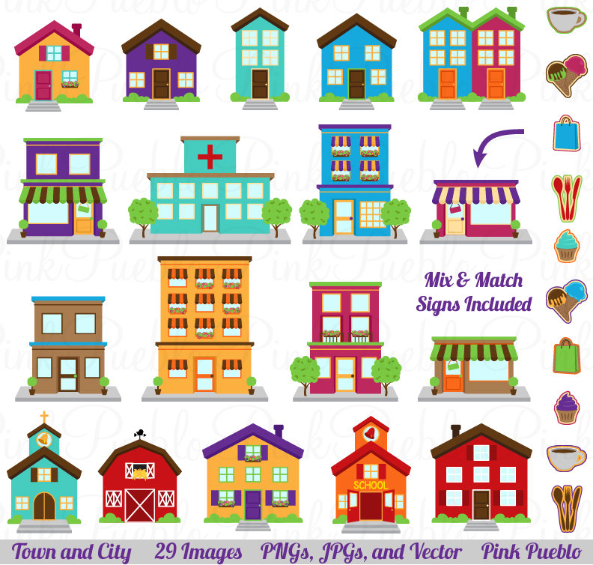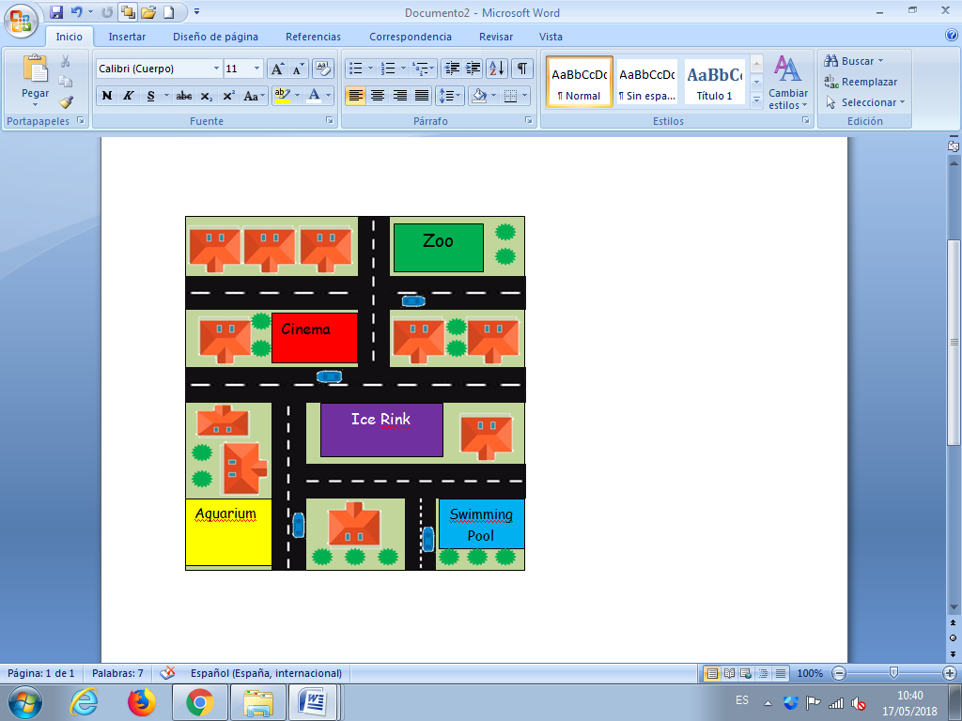

Now, draw your own town!

Welcome to _________

My town is called ________________.

In ________________, there is:

1. ________________________

2. ________________________

3. ________________________

4. ________________________

5. ________________________

In my town, the weather is always ________.

Everybody here likes to ________________.

My Town

In Seatown, there is…

1. ____________________

2. ____________________

3. ____________________

4. ____________________

5. ____________________

Is there a beach? **Yes / No**

Is there a cinema? **Yes / No**

Is there a funfair? **Yes / No**

Is there an ice rink? **Yes / No**

Look at the map. What can you see?

Welcome to Seatown!