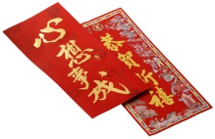

Chinese New Year

新年好

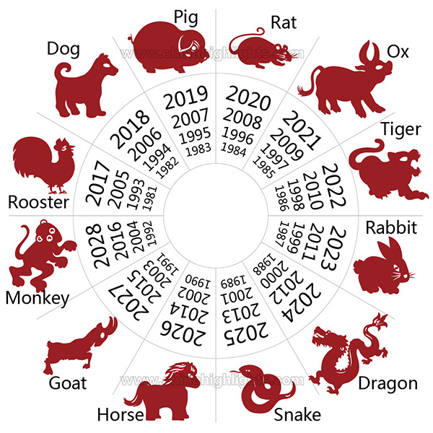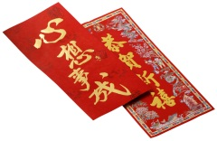

*Look in your dictionary for the meaning of the words that you don't understand.*

*How would you describe yourself? Does it match with your animal? Why, why not?*

**Bad**

**_____________**

**_____________**

**_____________**

**_____________**

**_____________**

**_____________**

**_____________**

**Good**

**­­­­­­­­­­­_____________**

**_____________**

**_____________**

**_____________**

**_____________**

**_____________**

**_____________**

The different animals have different adjectives to describe them-

* **Rat:** quick-witted, smart and manipulative
* **Ox:** patient, kind, stubborn and conservative
* **Tiger:** authoritative, irritable, emotional and courageous,
* **Rabbit:** popular, compassionate, secretiveness, and sincere
* **Dragon:** energetic, aggressive, fearless and warm-hearted,
* **Snake:** charming, gregarious, introverted, generous, and smart
* **Horse:** energetic, independent, impatient, and enjoy traveling
* **Sheep:** mild-mannered, shy, lack of independence kind, and peace-loving
* **Monkey:** fun, arrogance, energetic, ,and active
* **Rooster:** selfish, independent, practical, hard-working, and observant
* **Dog:** patient, diligent, generous, obstinate, faithful, and kind
* **Pig:** loving, tolerant, honest, naive and appreciative of luxury

**Which of these adjectives are good, which are bad?**

The Chinese Zodiac is made up of twelve animals. These are the- Rat, Ox, Tiger, Rabbit, Dragon, Snake, Horse, Goat, Monkey, Rooster, Dog and Pig.

You can find out what animal you are by looking at the chart

What animal are you? ___________________________