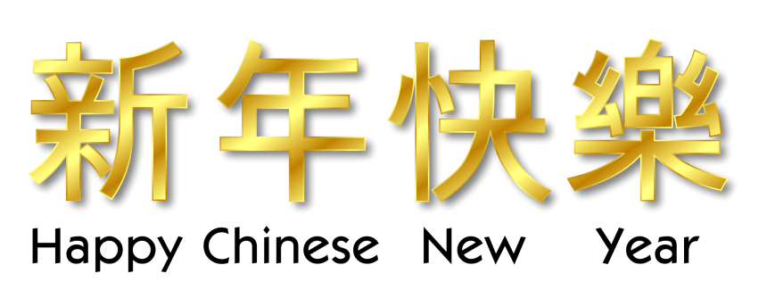
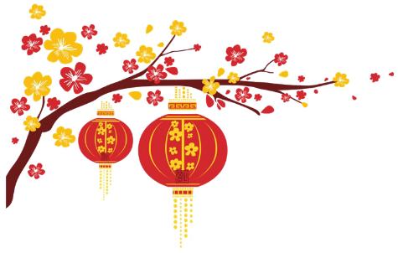

Listen and Put the pictures in the correct places in the sentences. https://english-portal.com.ua/worksheet/Happy_Chinese_New_Year#topadv
There are three pictures you do not need.
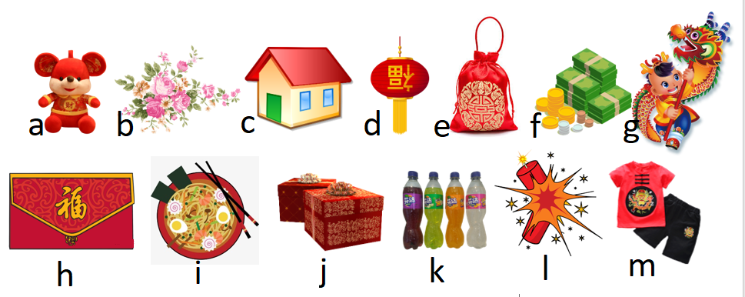
Soon it will be Chinese New Year. We’re cleaning our 1……… and putting 2……. everywhere. We set off 3……. to scare away any bad spirits and to welcome the New Year. It’s the first day and I’m wearing new 4……. for the new and good things to come. My brother and I are each given an 5…… with 6……. inside. The envelopes are red – a colour of luck. Today, our family and friends bring 7……. and 8……….. We sit down and enjoy a great feast. We watch the amazing lion and 9…….. dances. On the last day of the festival we hang up the 10…….. outside and wish for good luck in our special New Year.

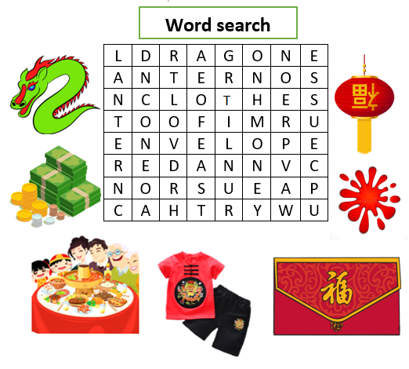
Match

1.Clean the | a. lanterns
2. Set off | b. amazing dances
3. Scare away | c. house
4. Red | d. luck
5. Enjoy a | e. firecrackers
6. Watch | f. bad spirits
7. Hang up | g. a great feast
8. Good | h. envelope

Answers
Listen and Put the pictures in the correct places in the sentences.
- C
- B
- L
- M
- H
- F
- I
- K
- G
- D
Match
- C
- E
- F
- H
- G
- B
- A
- D
