Name: _______________ Date: _____________
LO: I can care for a living thing
After finding out that trees are great for our environment, let’s get planting!
Seeds inside apples or conkers from a horse-chestnut tree can be planted in soil and if they are looked after correctly, will grow into an apple tree or another horse chestnut tree!
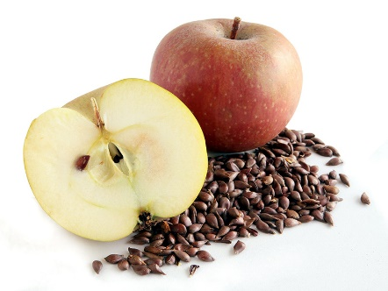
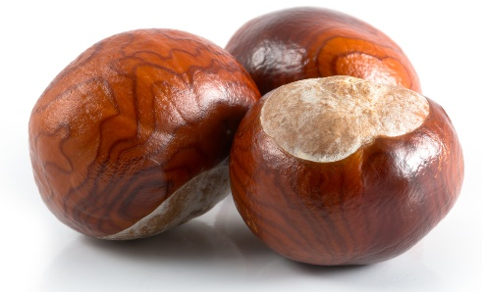

Your topic task today is to plant a tree seed – any you like and can get your hands on!
Pop it in a plant pot inside first and watch it each day – after a couple of weeks it should start to sprout!
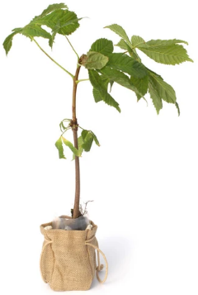
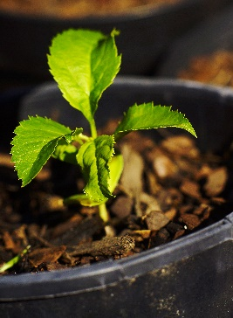

After a loooooong time (maybe a couple of years!) your tree might be big and strong enough to move into your garden – that’s when it will really start helping our environment.

