Name: _______________ Date: _____________
REMEMBER
Capital letters, full stops and finger spaces!
LO: I can use time conjunctions
As we know, trees are really helpful in looking after our environment and keeping us healthy. They create oxygen which our bodies need.
Have a look at the life cycle of a tree – can you add in these time conjunctions and topic words to complete the sentences? Write them out using pencil and paper. TOP TIP – use each word only once as it appears in the list.
fruit Next, grows seeds Finally, ground First, seeds After that, shoot tree tree seeds

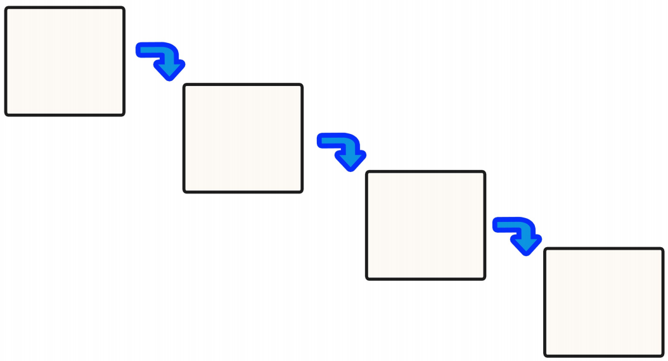
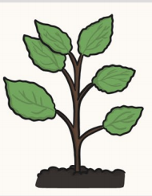
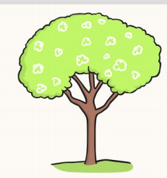
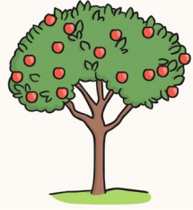
_____, the ____ fall onto the _____.
____, the ______ grows _____ with more _____!
____, the shoot ____ into a ____.
______, the ____ sprout into a ____.

