Name: _______________ Date: _____________
LO: I can use time conjunctions
As we know, trees are really helpful in looking after our environment and keeping us healthy. They create oxygen which our bodies need.
Have a look at the life cycle of a tree – can you add in these time conjunctions to help show the order that the cycle happens?
Next, Finally, First, After that,
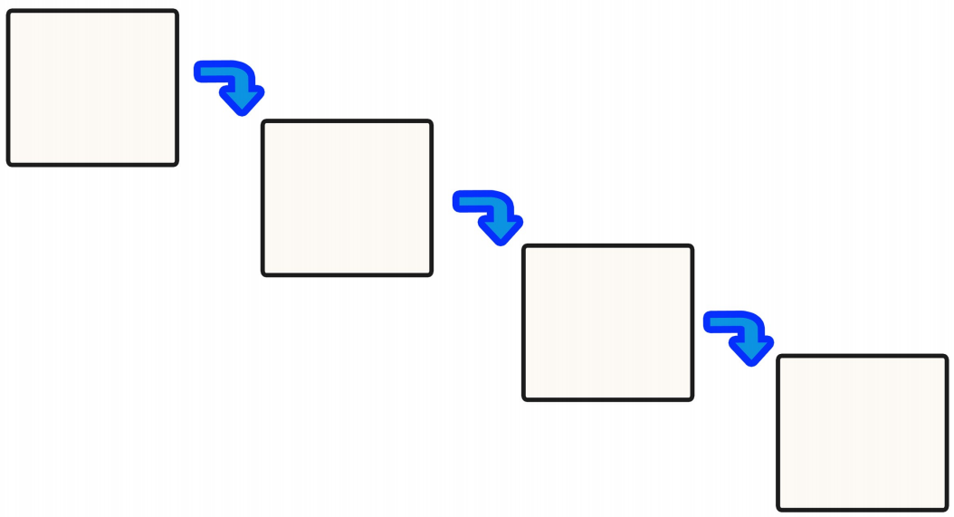
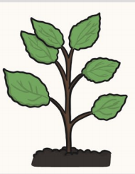
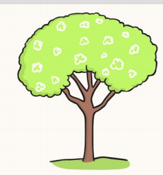
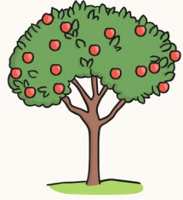
__________________, seeds fall onto the ground.

_____________, the tree grows fruit with more seeds!
__________________, the shoot grows into a tree.
__________________, the seed sprout into a shoot.

