Name: _______________ Date: _____________
LO: I can label the parts of a tree
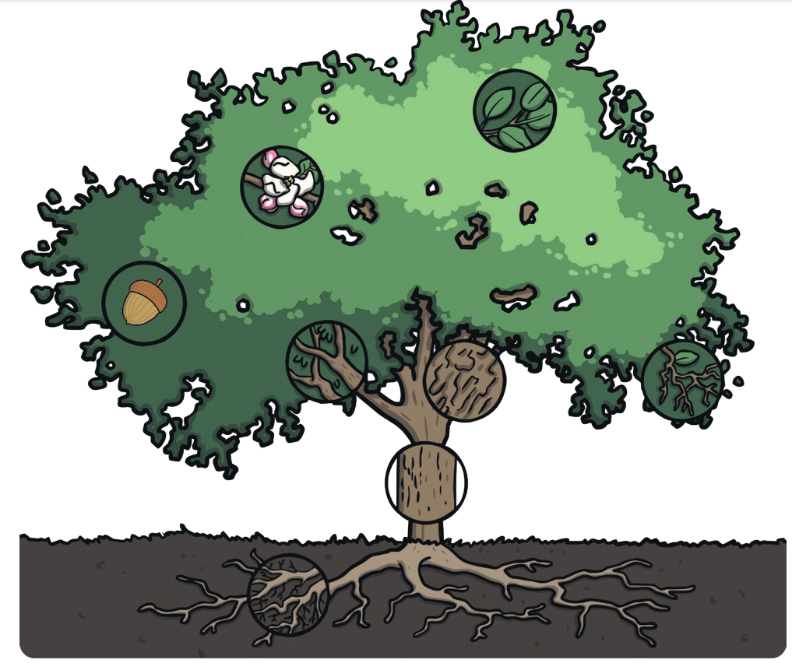
Match the labels to the parts of the tree! You might like to draw your own tree and label the parts of that.
leaves root branches
bark blossom twigs
trunk

CHALLENGE: Do you know what each of the part of the tree does?
Check out the English HOT task for the suggestions! Write out each label and the job it does on a separate sheet.

