Name: _______________ Date: _____________
LO: I can label the parts of a tree and their purpose
Well done for labelling the parts of the tree!
Which part does which job? Write the sentences out on a piece of paper with a pencil, adding in the parts of the tree.
REMEMBER – full stops, capital letter aaaaaaand finger spaces
The _____ soak up the sun for food. | The ______ soak up the water for food. | The _______ let the food travel to the twigs and blossom to help it grow.
The ______ is like a shell which protects the tree from animals and humans. | The ______ is like the spine of the tree – connects it all together! | 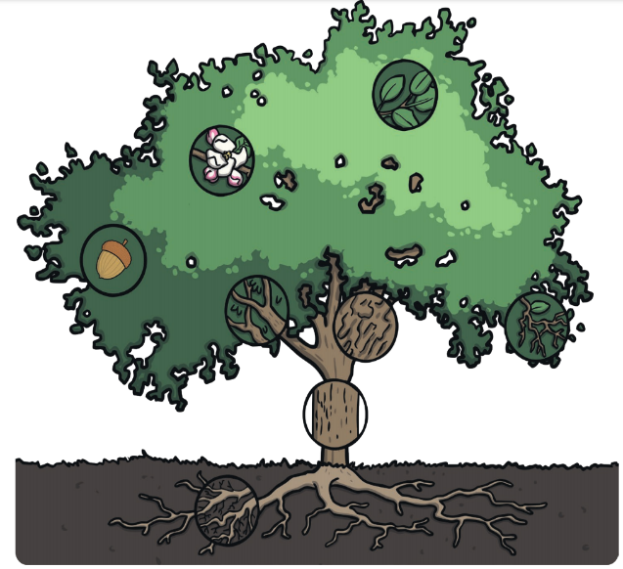
The ______ use the food to start growing bigger. | The _______ is little flowers which feed the insects.

